AWS - Configure an AWS Application Load Balancer (ALB) Using Path-Based Routing
Pre-requisites:
- Create an AWS account
-Create a Json template format which could automatically generate the creation of one or two instances.

On CloudFormation,
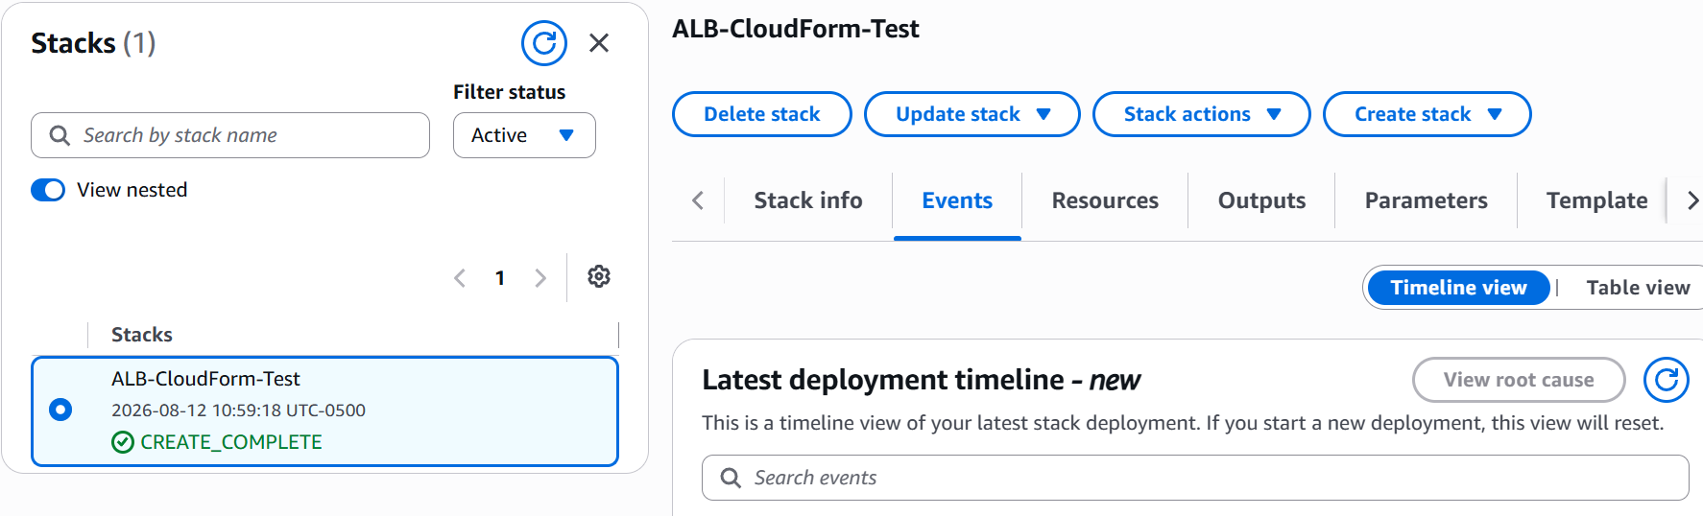
Perform a normal check to see if our web application responds
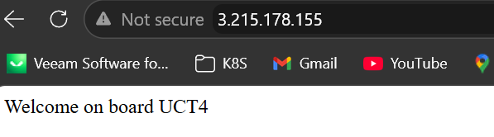
Let’s check on EC2 if the instance has been created as well
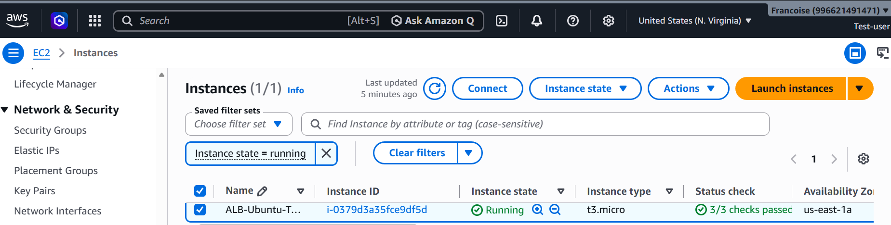
Now, let’s create a target group
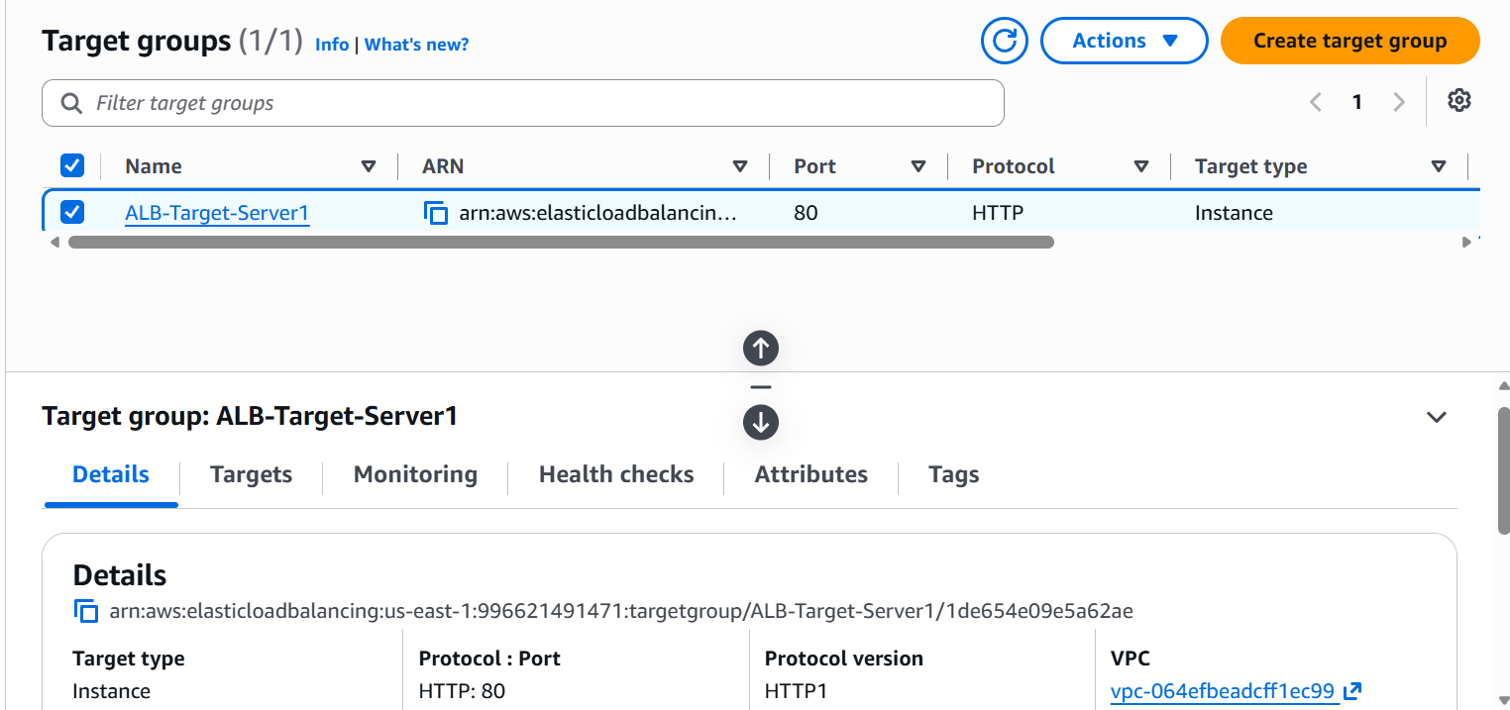
Once the target group has been created, create a load balancer where we could test our DNS server
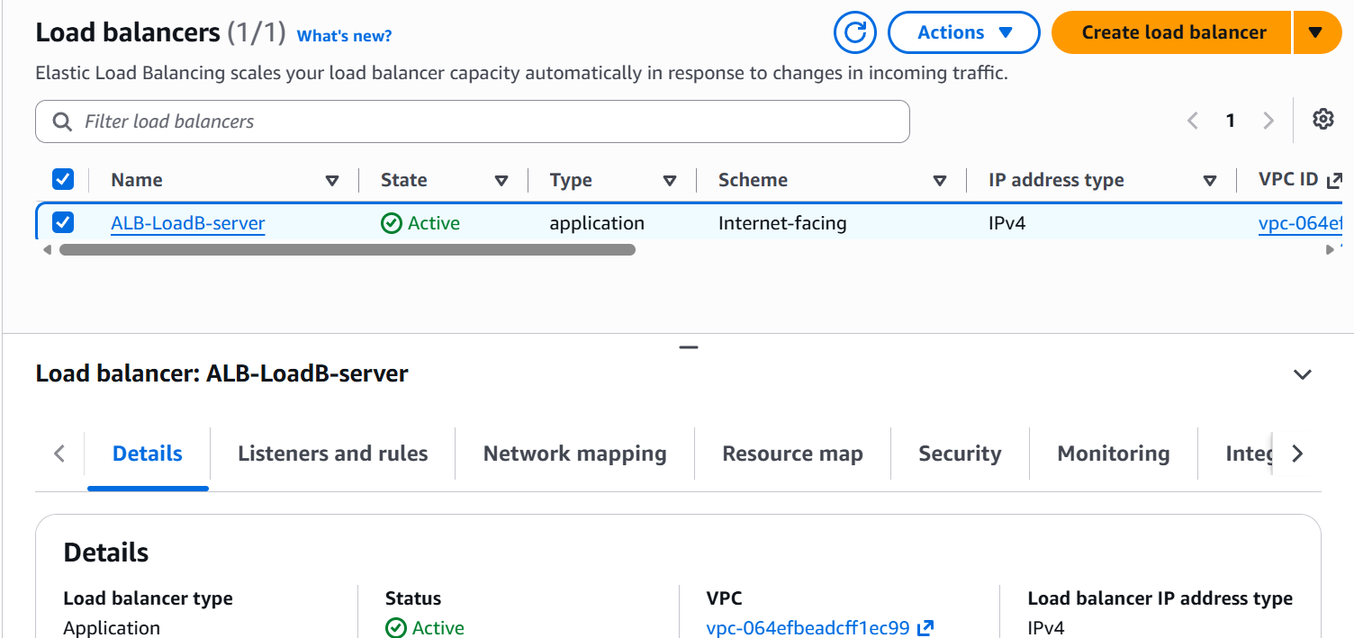
Copy the DNS link on your browser and test if it works
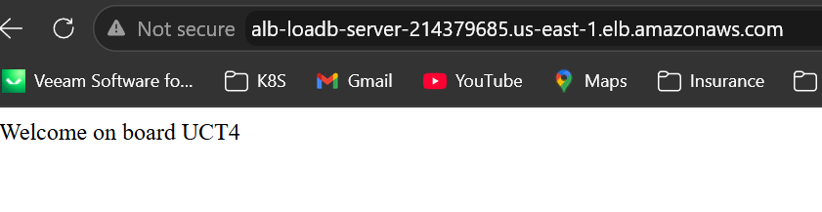
Under load balancer, configure the listener and add the path
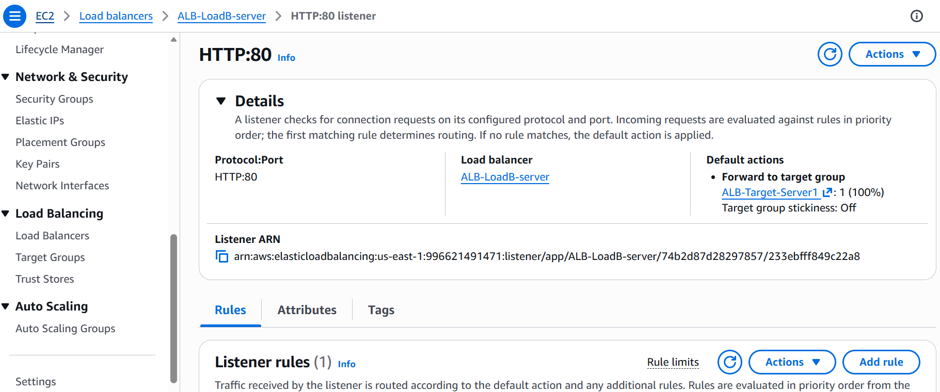
Click on “add rule” and configure the listener
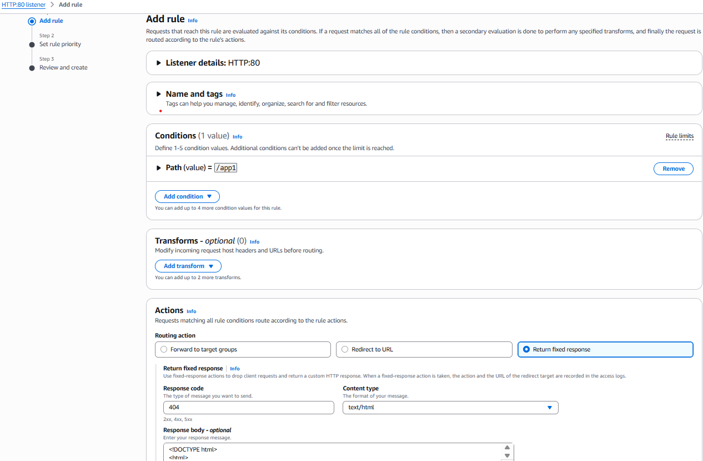
Next step is to set up the rule priority. It is important to know that the priority will be considered from the lowest to the highest request number
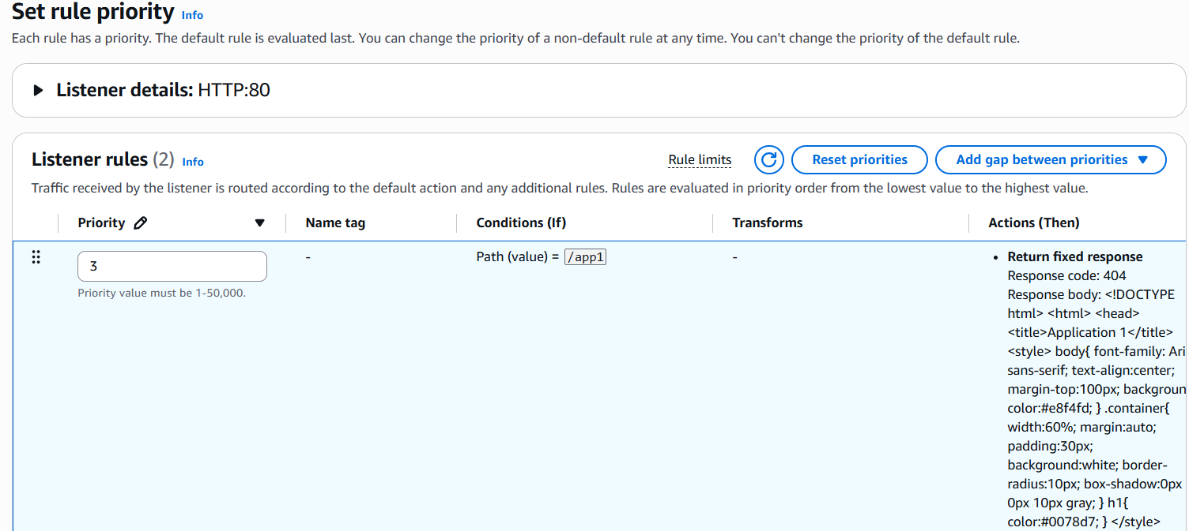
Since we need to forward the request into two webpages, do not forget to create the second listener named /app2 in this case.
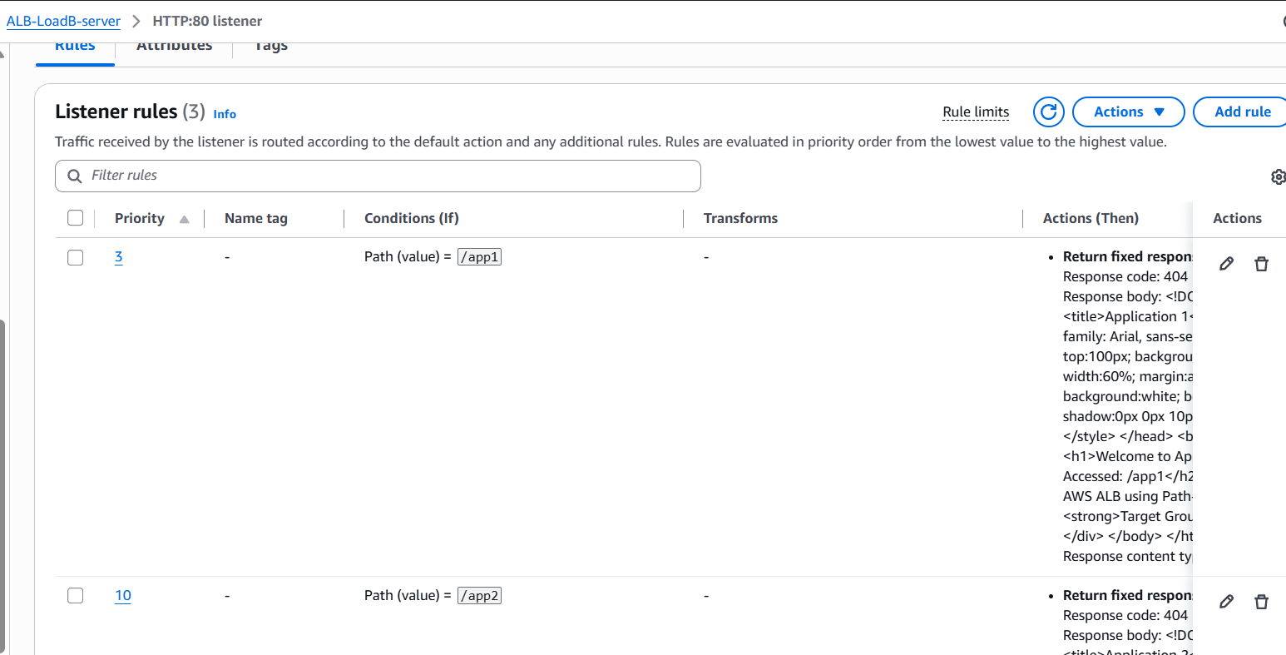

Let’s now test these two web applications by just adding /app1 and /app2 at the end of the DNS name.
